

**DDWD 3723 - SOFTWARE DEVELOPMENT**

**PROJECT PROPOSAL FORM**

Session/Semester : 2024/2025 - Semester 5

**Instruction:** Please complete and submit this form to the respective lecturer. The proposalmust be reviewed by the lecturer before proceed with the project.

|  |  |  |  |  |  |  |  |
| --- | --- | --- | --- | --- | --- | --- | --- |
| **SECTION A: STUDENT INFORMATION** | | | | |  | | |
|  | | | | | | | |
| Name 1 | | **:** Fakhrul Hilmi Bin Azman | | | |  | |
| Name 2 | | **:** Chei Kah Yan | | | |  | |
| Name 3 | | **:** Nur Alhuda Binti Mahmoud Ahmed Shokr | | | |  | |
| Name 4 | | **:** Nur Rifqah Binti Shahrul | | | |  | |
| Name 5 | | **:** Toh Khim Tat | | | |  | |
|  |
| Year/Course | | **:** 5 DDWD | | | |  | |
|  | | | |  | | |  |
| **SECTION B: PROJECT DETAILS** | | | |  | | |  |
|  | | | | | | |  |
| **Lecturer Name** | | | **:** Noor Diana Binti Mohamed Hassim | | | |  |
| **Project Title** | | | **:** BHPS Book Heaven Purchasing System | | | |  |
| **Project Type** | | | **:** Website | | | |  |
| **Client Name** | | | **:** Book heaven | | | |  |

**Problem Background and Proposed Solution:**

Paragraph 1 – Facts / Company Overview / Business Nature  
Book Heaven Sdn. Bhd. is a Malaysian-based company established in 2020, specializing in the sale of books across various genres, including fiction, non-fiction, educational, and children's literature. The

company operates a physical bookstore located in Kuala Lumpur, catering to students, professionals, and casual readers. Known for its curated selection and friendly customer service, Book Heaven aims to promote a strong reading culture in the community.

Paragraph 2 – Problem Background.

Lately Book Heaven Sdn. Bhd. faces several challenges in meeting customer needs. Many book enthusiasts and hobbyists often encounter limited space to store their growing collections, making it difficult to continue purchasing physical books. In addition, popular and trending titles tend to sell out quickly, leaving many customers unable to obtain the books they want.

Paragraph 3- Proposed Solution

To address these challenges, BHPS Book Heaven plans to develop a fully functional online bookstore website. The platform will allow customers to browse the catalogue, search for titles, read book descriptions, and make secure purchases anytime, anywhere. Features such as personalized recommendations, e-wallet payment options, and delivery tracking will enhance customer convenience. By transitioning to an online sales channel, the company can expand its market reach nationwide, increase sales volume, and remain competitive in the evolving retail landscape.

**Project Aim:**

The aim of this project is to design and develop a user-friendly online bookstore website for BHPS Book Heaven Sdn. Bhd. that expands market reach beyond its physical store, enhances customer convenience through digital shopping features, and increases overall sales and competitiveness in the Malaysian book retail industry.

**Objectives:**

1. To develop the BHPS book heaven purchasing process in the website.

2. To design and develop the BHPS Book Heaven Purchasing System.

3. To evaluate the accuracy and correctness of the data taken.

**Scopes:**

The project will involve the create, read, update, and delete of an online bookstore website for BHPS Book Heaven Sdn. Bhd.

**Project Requirements:**

|  |  |  |  |
| --- | --- | --- | --- |
| Methodology | | The development of the BHPS Book Heaven Online Bookstore will follow a agile with scrum, ensuring that the project is completed systematically and meets the company’s objectives. | |
| Programming Language | | HTML, PHP, CSS, JavaScript | |
| Framework | | Next.js | |
| Database | | GitHub | |
| **Software** | | | |
| Project Management | GitHub Desktop, Trello, Microsoft Project | | |
| Documentation | Microsoft Word, Microsoft PowerPoint | | |
| Development / Design | Canva, Google Chrome, Microsoft Edge, GitHub, Bootstrap, xampp | | |
| **Hardware** | | | |
| Developer | Hilmi | | 11th Gen Intel(R) Core(TM) i5-11400H, 8GB RAM (MSI) |
| Chei Kah Yan | | Intel Core i5-12500H, 16GB RAM (ASUS) |
| Nur Rifqah | | Laptop- 13th Gen Intel(R) Core(TM) i5-1335U , 24.0 GB RAM (ASUS) |
| Document Maker | Nur Alhuda | | Laptop - Intel Core i5, 16GB RAM (Lenovo) |
| Toh Khim That | | Laptop – Intel(R) Core(TM) i5-6300U, 8.00 GB RAM (Lenovo) |

**Project Budget Estimation:**

|  |  |  |  |  |
| --- | --- | --- | --- | --- |
| **Development** | | | | |
| **No.** | **Item** | **Quantity** | **Price Per Unit** | **Total Price** |
| 1 | Website Template (medijix.com) | 1 | 56.11 | 56.11 |
| 3 | Hosting for 1 Month (000webhost.com) | 1 | 12.57 | 12.57 |
| 4 | Box for making door prototye | 5 | 0.00 | 0.00 |
| 5 | Steel / Rod / Spring for making door prototype | 3 | 0.00 | 0.00 |
| 6 | Acrylic Board A3 for making door prototype | 3 | 0.00 | 0.00 |
| 7 | Acrylic Paint Set for making door prototype | 1 | 0.00 | 0.00 |
| **Total** | | | | 0.00 |

|  |  |  |  |  |
| --- | --- | --- | --- | --- |
| **Documentation** | | | | |
| **No.** | **Item** | **Quantity** | **Price Per Unit** | **Total Price** |
| 1 | Document Printing   * Proposal Slide (1st Version) * Proposal Report (1st Version) * Proposal Slide (Last Version) * Proposal Report (Last Version) * SDP (Last Version) * SRS (Last Version) * SDD (Last Version * STD (Last Version) * SUM (Last Version) | 1 | 0.00 | 0.00 |
| 2 | Comb Binding | 5 | 0.00 | 0.00 |
| 3 | Poster A1 Print | 1 | 0.00 | 0.00 |
| 4 | Poster A1 Laminate | 1 | 0.00 | 0.00 |
| 5 | Brochure A4 Print | 30 | 0.00 | 0.00 |
| 6 | Project Progress Report (Orange Book) | 1 | 0.00 | 0.00 |
| 7 | Pendrive 8Gb | 1 | 0.00 | 0.00 |
| 8 | Canon G3010 Ink Printer (Black) | 1 | 0.00 | 0.00 |
| 9 | Canon G3010 Ink Print (Color Set) | 1 | 0.00 | 0.00 |
| 10 | A4 Paper (Per Ream) | 1 | 0.00 | 0.00 |
| 11 | A4 Plastic Cover (Per Sheet) | 20 | 0.00 | 0.00 |
|  |  |  |  |  |
| **Total** | | | | 0.00 |

|  |  |
| --- | --- |
| **SECTION C: PROJECT PLANNING** |  |

**Organization Chart:**

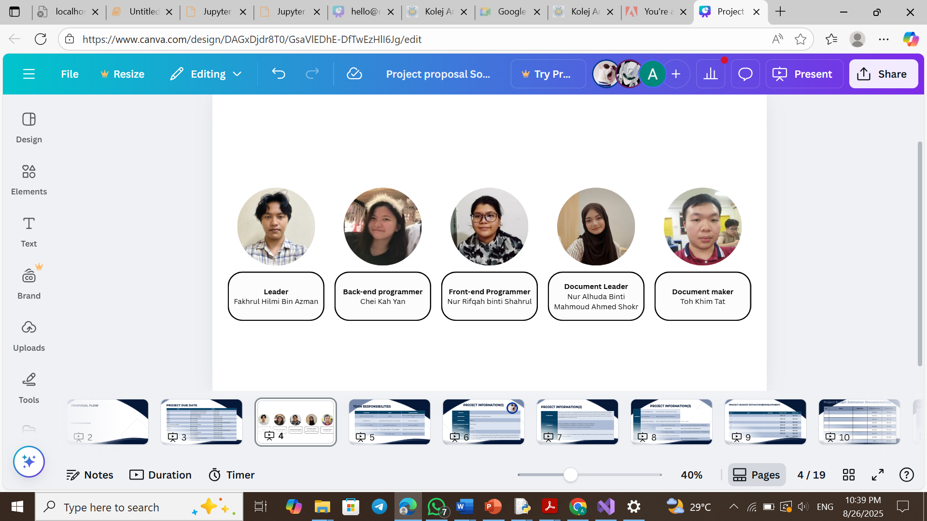

**Team Responsibilities:**

|  |  |  |  |
| --- | --- | --- | --- |
| **No.** | **Member Name** | **Roles** | **Responsibilities** |
| 1 | Fakhrul Hilmi Bin Azman | Leader | Build up database and guide our team work |
| 2 | Chei Kah Yan | Back-end Programmer  GitHub Owner | Build up website |
| 3 | Nur Rifqah Binti Shahrul | Front-end Programmer | Build up website |
| 4 | Nur Alhuda Binti Mahmoud Ahmed Shokr | Document Leader/ Trello Manager | Make documentation report and slide |
| 5 | Toh Khim Tat | Document Maker | Make documentation report and slide |

**Gantt Chart (Microsoft Project Only)**

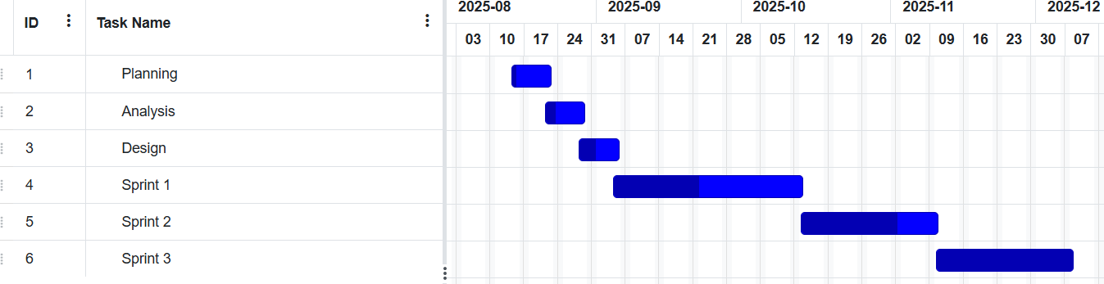

**Work Breakdown Structure**



**Pertt Chart (Network Diagram) and Critical Path:**



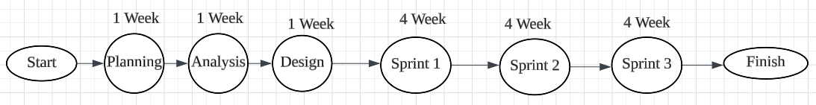

|  |  |
| --- | --- |
| **SECTION D: PROJECT FEATURES** |  |

**Project Features:**

|  |  |  |
| --- | --- | --- |
| **User** | **Staff** | **Admin** |
| View homepage | Sign In | Sign In |
| View menu | Forgot Password | Forgot Password |
| Make order | Sign Out | Sign Out |
| Pay order | View Dashboard | View Dashboard |
| View receipt | View order | View Sales Report |
| Get receipt by email | Change password | View order |
| View about US | Cancel order | Cancel order |
| View contact us | View Profile | Change password |
| View feedback | Edit Profile | View profile |
| View order status | View Sales Report | Edit profile |
| Sign in | Download sales report | Download Sales Report |
| Forgot password | Add menu | Add staff |
| Sign out | Delete menu | Delete staff |
| View Profile | Edit menu | View staff |
| Edit profile | View about us | Edit staff |
| View Booking History | Update order status | Update order status |
| Event | View Feedback | Add menu |
|  | Edit event | Delete menu |
|  | Delete Event | View menu |
|  | Add Event | View feedback |
|  | View booking | Edit menu |
|  | Cancel booking | Edit about us |
|  | Edit booking | Edit cantact us |
|  | View List of customer | Edit event |
|  | View sales report | Delete event |
|  |  | Add event |
|  |  | View booting |
|  |  | Cancel booking |
|  |  | Edit Booking |
|  |  | View List of custemer |
|  |  | View staff |
|  |  | Add staff |
|  |  | Edit staff |
|  |  | Delete staff |
|  |  | View sales report |